1. Enter the type of component I,e:- Series or Parallel

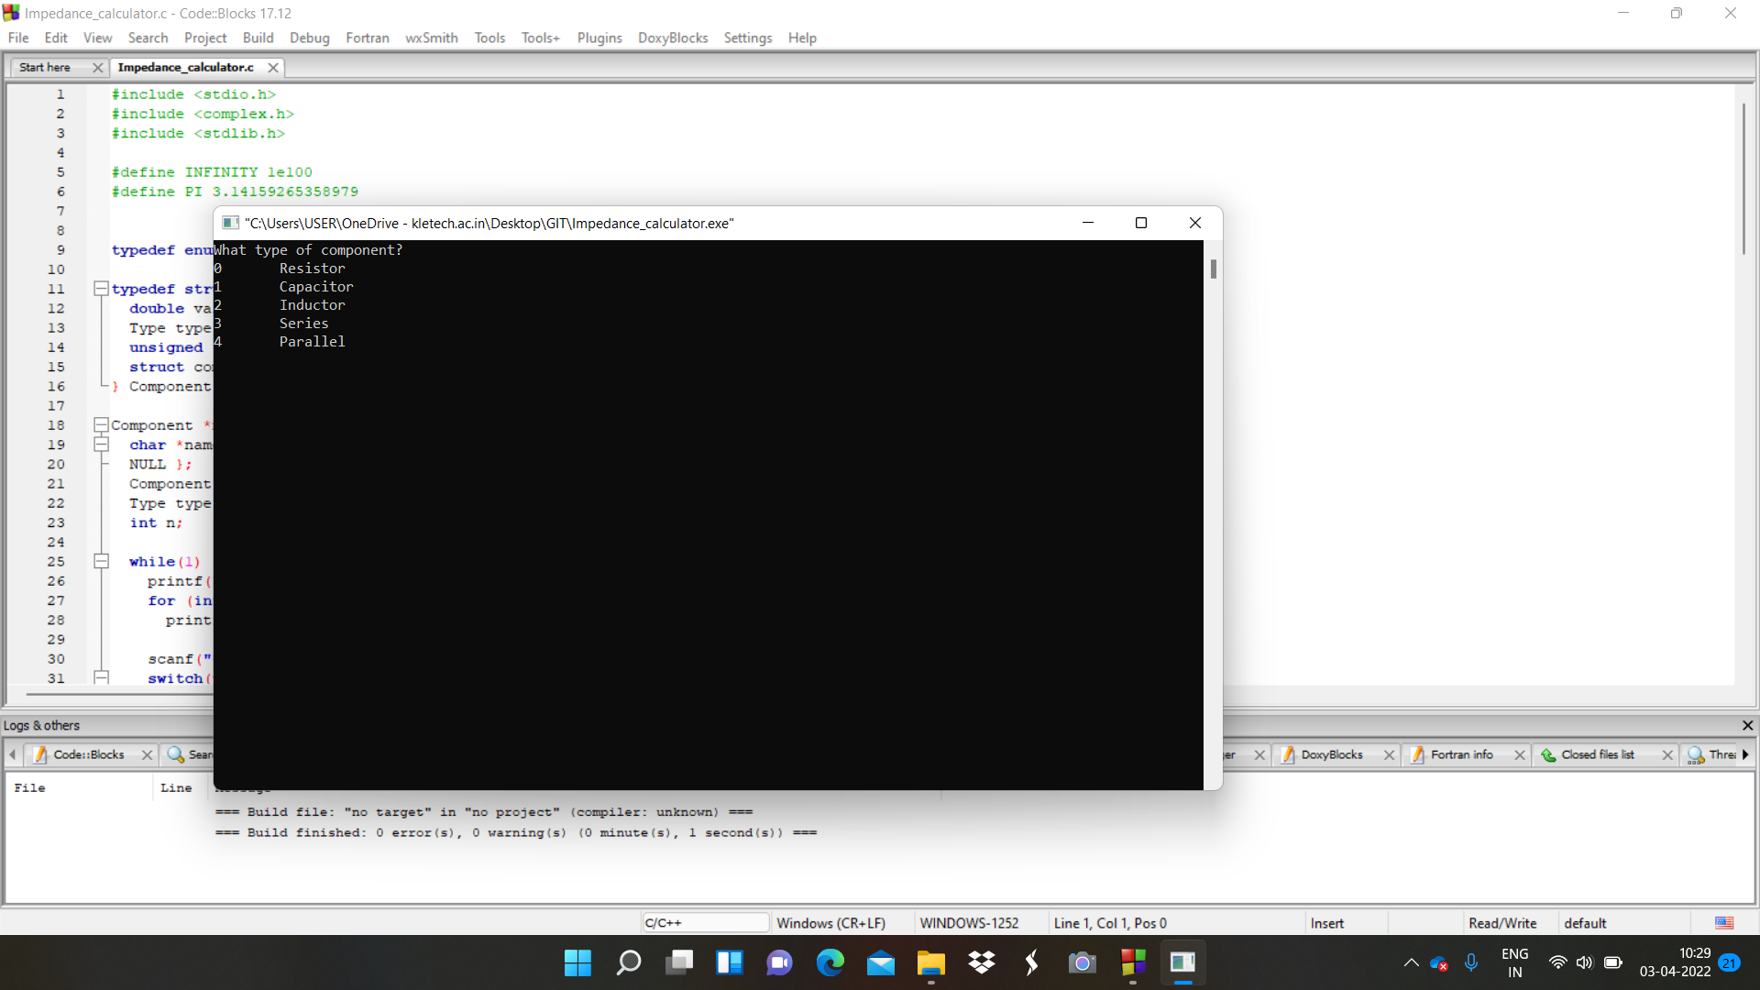

1. Enter the number of nodes present in the circuit

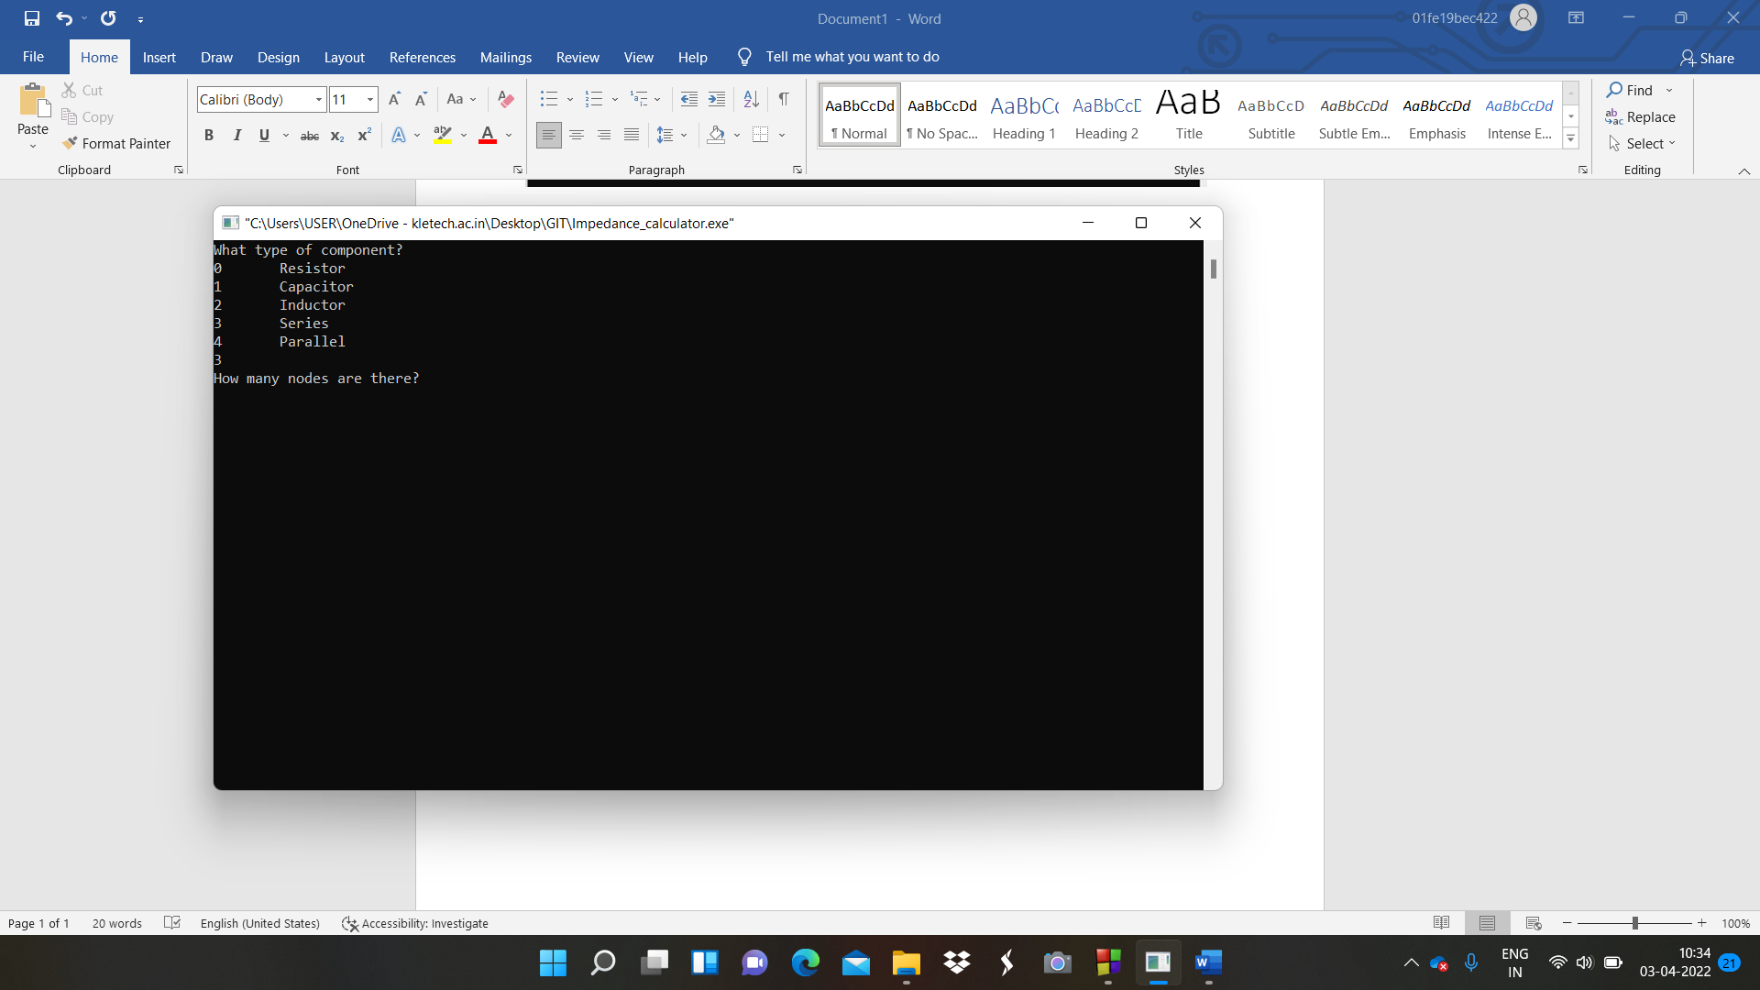

1. Enter the type of component I,e:- Resistor or Capacitor or Inductor

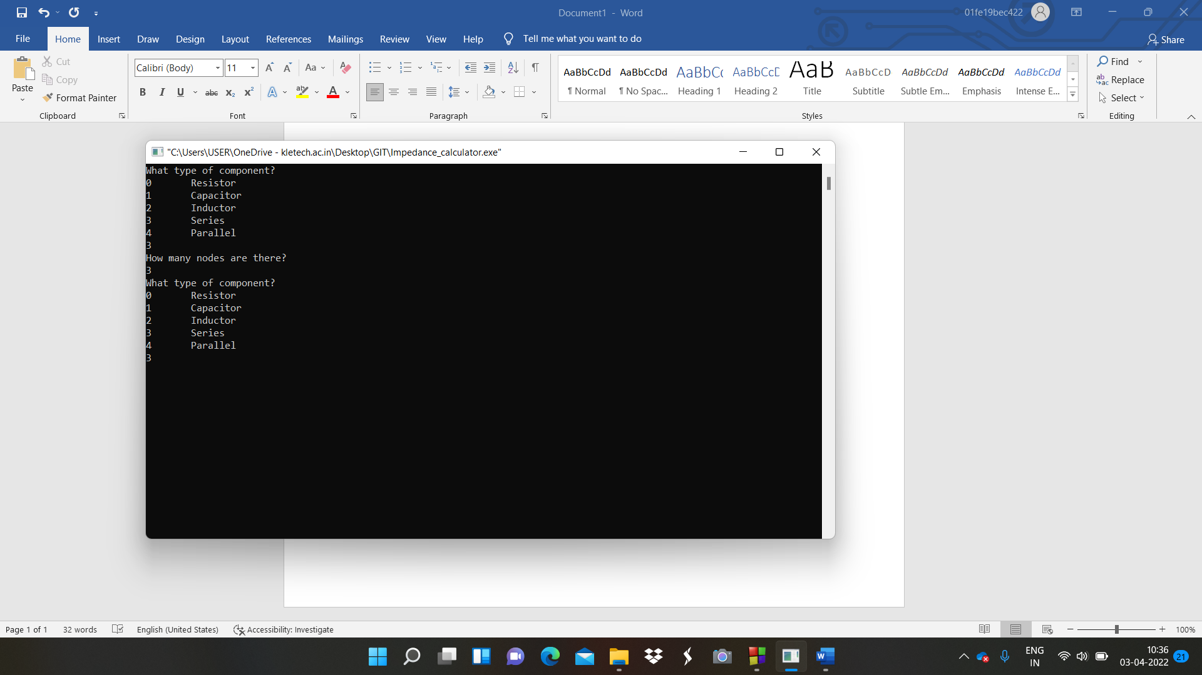

1. Enter the value of the components I,e:- Resistor or Capacitor or Inductor

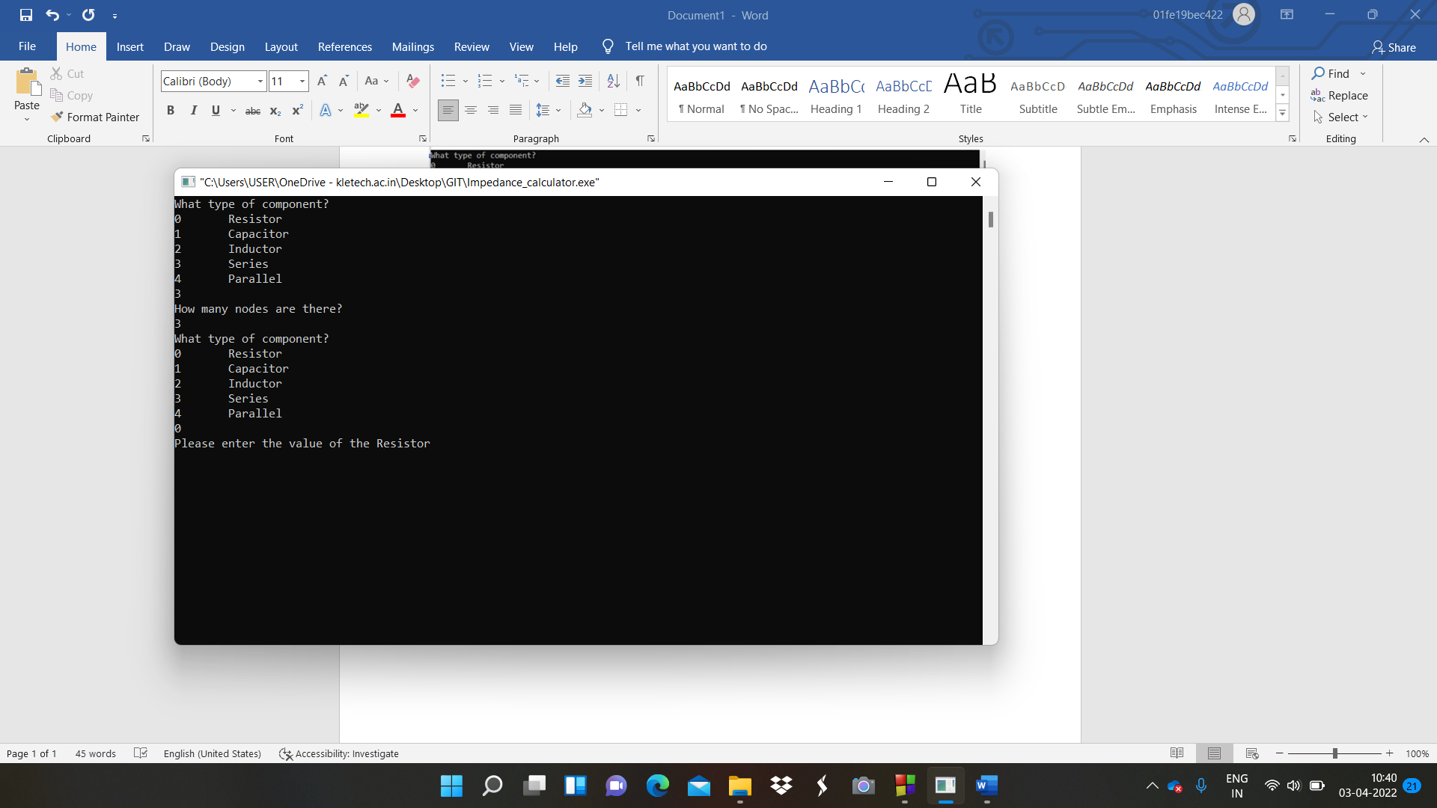

1. After entering all components value then we got Impedance value calculated

